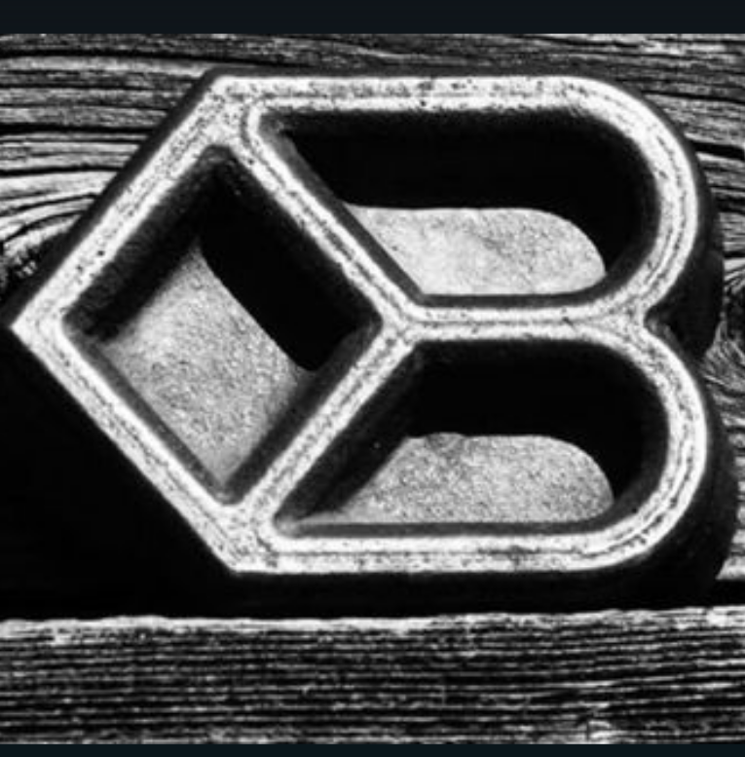
Diamond B Quarter Horses
Josh and Annie Bostrom
Grangeville, ID 83530
(208) 413-4349

TRAINING AGREEMENT made this _____ day of __________ 20__, by and between : _________ _____________ hereinafter referred to as "Owner", and Josh Bostrom / Diamond B Quarter Horses hereinafter referred to as "Trainer".

By bringing the below named horse to Diamond B Quarter Horses, the owner is in agreement to receive training services from Diamond B. Furthermore, Owner agrees Diamond B is a fit and qualified trainer for the below named horse, and that Diamond B premises and facilities will provide an adequate and reasonable level of safety for Owner’s horse(s).

Disclosure of Information About Horse to be Trained
Name of Horse_______________________________ Age ___________ Breed____________________ Color _____________ Sex ____________
Fee Agreement
Fees for each service(s) will vary as all services depend greatly on the individual physical and mental ability of each horse. The following list provides the Owner with a baseline of fees for training.
-Colt Starting (30 Days): $700.00
-Mule Training (30 Days): $700..00
-60 plus days horse/mule: $650.00/30 days
- Consignment Sales: 10% of sale price plus fees for rides and feed while with Diamond B.

Above fees include training, and hay. Any additional feeds (i.e. grain or supplements) must be provided by the owner. Trainer will provide daily care (i.e. feeding) at no additional charge. In the event that the horses stay falls on a time where the trainer has prior obligations (i.e. traveling for emergencies or work) Trainer will contact Owner and add $3 per day for feed consumed by the above named horse during that time. In the event that a farrier’s services are required, Trainer will notify Owner and Trainer will contact his regular farrier unless the Owner has a different farrier of choice in the area of said horses location while in training. Owner will be responsible for fees incurred by farrier.
Horse Health Warranty
Each horse shall enter the Trainer's premises free from transmittable diseases and must be effectively wormed, and current on immunizations for this area at least 14 days prior to arriving at the training facility. Horse must also have had a dental within the past 11 months, dental records will need to be provided. If your training falls on a month that our equine dentist is at our location your horse can be scheduled at that time. Every horse that is on our property at the time of our dentist days here will be evaluated and if found to need work owner will be contacted.

In Event of Horse Illness or Injury
Should the horse(s) become sick or injured, Trainer shall attempt to telephone the Owner immediately. If Owner does not immediately inform Trainer regarding measures to be taken, or if the state of the animal’s health requires immediate action in the Trainer’s opinion, Trainer is authorized to request the services of a veterinarian of his choice or to give any other attention that appears necessary. The Owner shall promptly pay all expense for all services.

Trainer’s Right to Refuse Services
Trainer reserves the right to refuse the continuation of training services of any horse(s) for any reason. At which time, the Trainer will refund the training fees pre-paid, less the booking fee and fees for training received.
Upon termination and or completion of training, Trainer shall have a lien on said horse(s) under Idaho law for all unpaid charges on account. Payment must be made in full before said horse is released unless Trainer consents otherwise in writing.

Owner Right of Termination
Upon notice to the Trainer, the Owner may terminate this agreement for any reason. Owner is not entitled to a full refund. Trainer shall be paid for all fees incurred up to the time of termination. After all fees have been paid in full, this agreement is concluded.

Entire Agreement
This contract represents the entire agreement between the parties. No other agreements, promises, or representations, verbal or implied, are included herein unless specifically stated in this written agreement. If no additional agreements, initial here ________.

OWNER(S) AND PARENTS OR LEGAL GUARDIANS, OR AUTHORIZED AGENT FOR SUCH PARTIES, MUST SIGN AFTER READING THIS ENTIRE DOCUMENT. ◊◊◊◊◊◊◊◊◊◊◊◊◊◊◊◊◊◊◊◊◊◊◊◊◊◊◊◊◊◊◊◊◊◊◊◊◊◊◊◊◊◊◊◊◊◊◊◊◊◊◊◊◊
SIGNER STATEMENT OF AWARENESS
I/WE HAVE READ AND DO UNDERSTAND ALL ABOVE INFORMATION.

________________________________ ________________________________
Diamond B Quarter Horses Owner
Josh Bostrom Printed:_________________________
Address_________________________
__________________________
Phone:______-_______-_____________

Please list any specific areas you would like us to focus on with your animal while in training.

