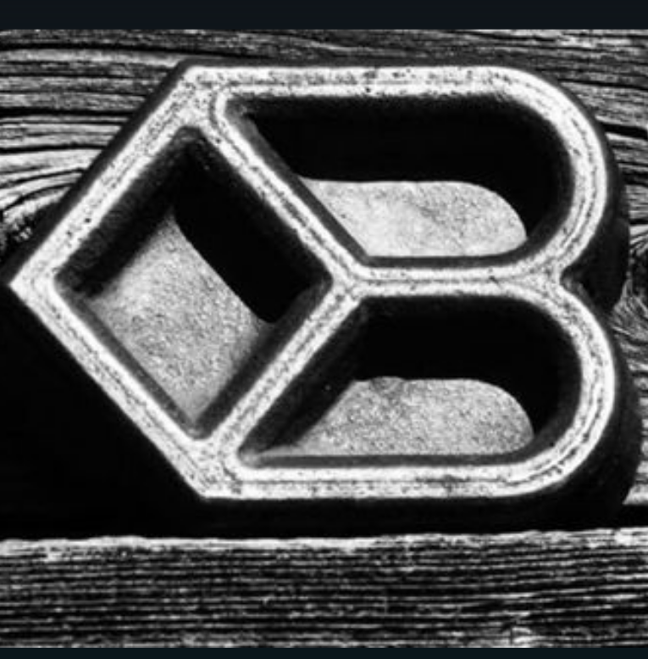
Diamond B Quarter Horses
Josh & Annie Bostrom
Grangeville,ID 83530
208-413-4349
www.diamondbquarterhorses.net

This contract is an agreement between ______________________, hereinafter known as the “mare owner” and Diamond B Quarter Horses owned by Josh Bostrom, hereinafter known as the “stallion owner” for the stallion XXX Macho Hancock, registration #5289606, hereinafter known as the “stallion”, to breed the following mare:_______________________, registration #____________, hereinafter known as the “mare”.

1. The breeding fee shall be $500 to include the following: a. A nonrefundable chute fee of $100 to accompany this signed contract and a copy of the mare’s registration papers.
b. Mare care of $5 per day wet or dry.$15 per day after mare has come out of heat. Also non refundable.
c. The balance of the stud fee will be paid in full before the mare leaves the premises.

2. Mare owner must provide transportation to Diamond B. If requested, Diamond B may provide transportation with mileage costs paid by mare owner at $1.50 per mile.

3. Mare must be able and willing to stand in chute for breeding. Diamond B reserves the right to utilize necessary safety restraints on mares (i.e. breeding collar, hobbles, ropes, etc).

4. If mare does not exhibit signs of a completed breeding cycle, the mare owner may be requested to have the mare checked by a licensed veterinarian to confirm status of breeding cycle.

5. After breeding, mare owner must have the above named mare “preg-checked” by a licensed veterinarian to confirm pregnancy within 20 days of breeding. If the mare does not conceive, the mare owner must notify Diamond B within 48 hours of preg-check appointment if rebreeding is desired.

6. Should the above named mare not conceive from breeding, the mare owner may schedule to rebreed the above mare during the current breeding season at no additional costs.

7. Live Foal Guarantee: If mare aborts, or if the foal does not stand and nurse; Diamond B will allow mare owner to rebreed the above named mare the following season with stud fee and chute fee being credited.
a. Diamond B must receive notification within one week of foal’s death. Diamond B may request a statement signed by a licensed veterinarian.

8. If the above named mare does not conceive during the current breeding season, the mare owner may choose to rebreed the above named mare during the following season. If the mare still does not conceive during the following season, the stallion owner may deem this mare unfit for service.
a. The scheduling of rebreeds will be at Diamond B’s discretion.

9 Should the above named mare die or become unfit for service and mare does not produce a live foal as a result of this breeding, the mare owner may choose to bring a substitute mare (with the discretion from the stallion owner. The mare owner will pay an additional chute fee. (This does not allow mare owner to sell or transfer breeding to another individual without Diamond B’s consent)

10. Should the stallion die or become unfit for service and mare does not produce a live foal as a result of this breeding, the stud fee will be refunded, not including the chute fee and mare care.

11. The mare owner agrees to not hold Diamond B responsible for any disease, accident or injury to the mare.

12. Breeding certificates to register the foal will be issued prior to the expected foaling date, granted that all required documentations have been provided to Diamond B and all bills are paid in full.

13. The mare owner agrees that this contract constitutes a lien upon the above named mare and her foal to secure payment of all charges. The mare owner is liable for the reasonable legal fees and costs to collect overdue charges.

14. Please list any exceptions to this breeding contract:_______________________________________________________ ________________________________________________________________________________ ________________________________________________________________________________________________________________________________________________________________ ________________________________________________________________________________

15. When signed by the mare owner and Josh Bostrom, this contract is binding on both parties under the laws of Idaho, subject to the conditions stated herein. This contract cannot be assigned or transferred to substitute mare or new mare owner without written consent of Josh Bostrom. By signing this contract mare owner acknowledges, understands and agrees to all items listed herein.

◊◊◊◊◊◊◊◊◊◊◊◊◊◊◊◊◊◊◊◊◊◊◊

________________________________ ________________________________
Diamond B Quarter Horses- Stallion Owner Mare Owner:
Josh Bostrom Address:_____________________________
_____________________________
Phone#:______________________________

